Using Log Files in Linux
Upon completion of this lab the student will be able to:
- Describe how to examine the log files in Linux
- Demonstrate the process of how to determine where an error has occurred
- Describe how to use the GUI Logs interface.
Background:
In this lab the student will work with the commonly used way to troubleshoot errors in a Linux system by using the logs. Journald is the new system for managing logs. We use journald to view and determine when a service failed to start and hos tom read the log files.
Lab Procedure
- Using Log Files in Linux
- Login to the server VM operating system.

- Open a terminal shell.

- Login as the root user once the shell comes up.

User Account | password
Student | Password1
su (root) | password

- Type: journalctl (to view every log entry in the system)
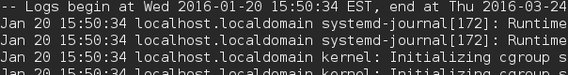

- Type: vi /etc/httpd/conf/httpd.conf

- Type: Hit the End key on keyboard and type any word (apache) at the bottom of the file.
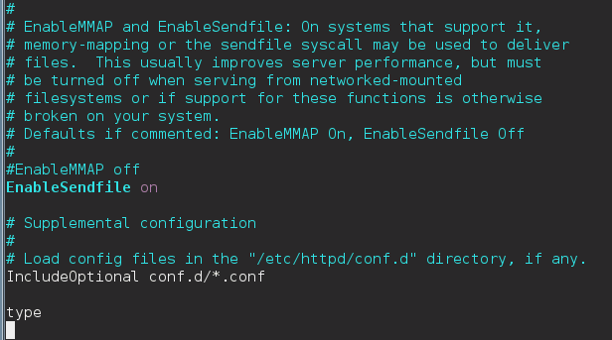
- Hit the Esc key on keyboard and type :wq to Save & Exit

- Type: systemctl stop httpd (stops the Apache server)

- Type: systemctl start httpd (attempts to start the Apache Server)

- Type: systemctl status httpd (See that the Apache did not start)
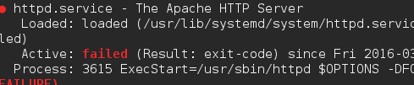

- Type: journalctl -u httpd and hit the End key on keyboard.
(to view error messages generated about the Apache server & see that it tell you there is an error on line 355 in the configuration file

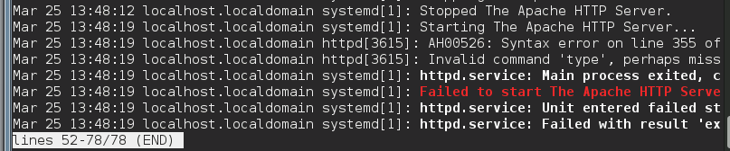
- Type the letter q on keyboard to return to a command prompt.

- Go back and remove the word added to the /etc/httpd/conf/httpd.conf file and resave the file (Steps 5-7).

- Type: clear on the terminal window.

- Type: journalctl –u httpd -f
(to go to the bottom of the journal log)

- Type: systemctl –failed (to see any failed modules)
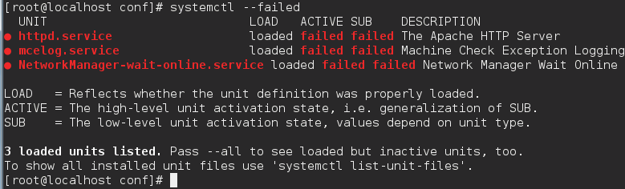
- Type: systemctl status httpd.service
(for each service that failed above)
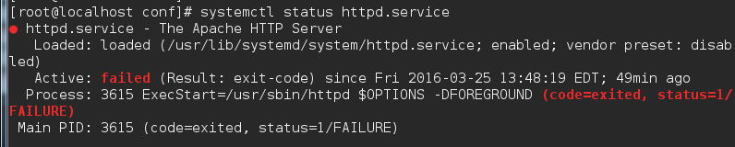
- Type: systemctl _PID=3615 (to see any errors related to the Process ID) (Notice the error message on Line 355)
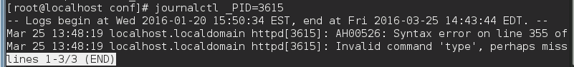
- Go to the httpd.conf file and remove /fix the error.

- Retry to start the service after fixing the error.
systemctl start httpd

- Check the status of the service to see if it start correctly.
systemctl status httpd

- There is a GUI interface for the Logs utility in Linux.
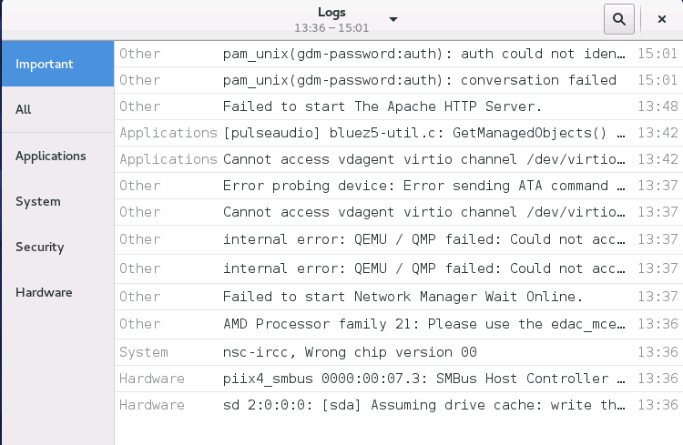
It must be installed to use – minimize any open windows.

- Click on Activities and enter to word logs in the search window.
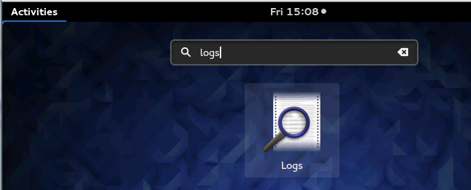
- Click on the icon for Logs and if it says Install click that button to install the application.
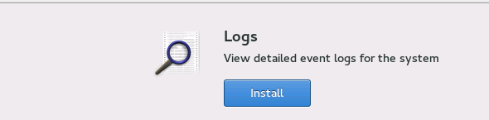
- This concludes this lab.

